Rhythm Rules
Chapter II from the book “Notes on Music”
by Carol and Louis Torres

God Created Harmony
As God planned this marvelous universe which was to be the playground of mankind, He was thinking in terms of eternity: Eternal happiness, eternal intrigue, eternal peace, eternal harmony. From the minutest particle to the most colossal, detail, glorious detail, was attended to and built into all that God created.
But not one detail, however apparently insignificant, was intended to stand alone but to be part of a whole. Every element was for the benefit of something else; always giving and thus always receiving. Cycles were within cycles and systems within systems. A “wheel within a wheel”: A Divine atmosphere of harmonious rhythms.
In our relatively small world, we never cease to be amazed by the intricacies and sensitive balance of our ecological systems. Nor do we cease to fear for the jeopardy into which we have placed our very survival as a result of our carelessness and indifference to just such harmony.

Man’s Harmony Based on Rhythm
This same balance, this same interrelationship and interdependence, cycles and rhythms, is very much apparent in the human body as well.
“We are essentially rhythmic creatures. Everything from the cycle of our brain waves to the pumping of our heart, our digestive cycle, sleep cycle — all work in rhythms. We’re a mass of cycles piled one on top of another, so we’re clearly organized both to generate and respond to rhythmic phenomena.” (Carole Douglis, “The Beat Goes On,” Psychology Today, November 1987, p. 42)
Each one of us has a personal rhythmic tempo that we exhibit in our speech, gestures and gait ranging from 60 to 120 beats per minute, with the majority of us clustered between 70 and 80 beats per minute. Interestingly, we tend to be most compatible with those whose rhythmic tempo is close to our own, a fact not too surprising when you stop to think of one’s attitude toward people we view as being on the “fast track” or “a little slow.” (Ibid., pp. 37-42)
These...
“...rhythmic or cyclic phenomena, characteristic of nature, are observed on all levels of biological organization. Within an organism, many physiological processes occur which are not only conspicuously rhythmical but also self-reinforcing and necessary for survival, such as brain activity, heart beat and pulse rate. All of these endogenous rhythms are synchronized with other cellular activities and are harmonic with body functioning.” (Gervasia M. Schreckenberg and Harvey H. Bird, “Neural Plasticity Of MUS musculus In Response To Disharmonic Sound,” Bulletin, New Jersey Academy of Science, Vol. 32, No. 2, Fall 1987, p. 81)

Disharmony Causes “Dis-ease”
The problems that arise from interfering with these cycles and rhythms of the body are very well known to medicine.
"If an organism is the target of excessive, disharmonic stimuli, a number of stress mechanisms, involving both endocrine and neural feedback, are subsequently evoked by the body. If these defensive actions become overburdened, then natural harmonic biological rhythms are disrupted, resulting in systemic disharmony and possibly even breakdown. If homeostasis cannot be attained then the stress condition can manifest itself in pathological disorders. In fact, fluctuations and disturbances in pre-existing body rhythms have been correlated with many diseases like diabetes, renal and hepatic disorders, ulcers, cancer and circulatory abnormalities (Reimann, 1963).
“Since most regulatory mechanisms are neural in origin, it is not surprising that many pathological alterations could also occur in neuronal structures. In the case of brain cells, this ‘disordering’ can manifest itself not only in the physical state of neurons but also in the harmony of their functioning, as well. Consequently, the behavior of the organism may become seriously affected.” (Ibid., p. 82)
Perhaps the most common and obvious expressions of this “disordering” process are the results of disrupting the sleep cycle. We are all very familiar with the results of such disruptions on children and the varying degrees of unpleasant behavior that follows. Not as common and well known are the terrible results of such disruptions used as torture against prisoners of war. Such graphic results serve to remind us that no one law of our being stands alone or can be considered inconsequential. Greater respect must be shown to the “total picture” surrounding mankind; his being, his world, his universe.

Music — Part of Creation
Just as there are natural laws that govern the physiology of our bodies and minds, so there are natural laws that govern music. These principles of good music have been established by careful observation and more recently, scientific study.
Believing that the “laws” of structure were arbitrarily imposed by men of less than current understanding, man, in the music world, as in many other disciplines, has tried to rearrange these laws for “special effects” or create new laws with no bonds or similarities to the “old.”
One reason for these detours might be found in the fact that, to many, the laws of music have seemed to be the results of mere preference.
Another reason doubtless stems from the fact that “Western” music appears to be dominated by the “Christian mind” as it differs so widely from styles used by the non-Christian societies of the world, even today. Any person, not wanting to be subject to Christian influences or wanting to prove “independent thinking,” would very naturally move away from the product of a Judeo-Christian culture.
A third reason that comes to mind is that, until very recently, the relationship of music to the health of society and our own personal health has largely been ignored, even considered nonexistent by most. Tastes in music have long been proclaimed to be merely a matter of personal choice thus leaving the field open for experimentation.

Music Is Rhythm
Music is made by combining and balancing five basic elements. These are:
- MELODY: tones arranged to make a tune;
- TONE COLOR: the quality of the sounds produced by instruments or the voice;
- HARMONY: the stacking of tones so as to create chords;
- RHYTHM: a specific allotment of time given to a note or syllable in verse and the time meter of a composition of music; and
- TEMPO: how fast or slow the rhythm is to be played or sung.
Though not obvious to the casual observer, all these elements consist of rhythmic vibrations and/or rhythmic cycles.
Tones are created by specific vibrations, the number of which determines the pitch and intonation of each tone. All sounds are vibrations. The universal “A” for example, vibrates 440 times per second. (With a universal music standard, it becomes conveniently easy to share music and players worldwide.)
Tone color is determined by the vibration of overtones as well as the presence or absence of surface sounds, sympathetic vibrations, and breath or mechanical sounds. These later sounds are often referred to as noise, or “dirty” sounds.
Harmony, of course, falls into the same category as it is simply the stacking of these vibrations. If the vibrations of these intervals, or chords, create “clean” sounds (the absence of secondary beats that have a slightly distorting effect on the pitch) we call the harmony “consonate.”
Examples of such consonate chords are thirds, fourths, fifths, and sixths. The perfect fourth and perfect fifth as well as a perfect octave comprise the most consonate sounds because the vibrations of their various tones together create no secondary beats. The third and sixth create a very slight secondary beat, not audible to most ears.
However, the secondary beats created by a second or seventh are noticeable, even to the untrained ear, These latter chords, or intervals, are referred to as being “dissonant.”
“Consonances provide stability and repose, while dissonances produce tension and motion by ‘pulling’ toward a resolution in a consonance.” (Willi Apel and Ralph T. Daniel, The Harvard Brief Dictionary of Music, (New York: Simon and Schuster, 1974) pp. 68, 69)
For the purpose of our overall discussion, consonance will be referred to as “harmonic” and dissonance as “disharmonic.”
The element of rhythm in music is primarily cyclic in nature, thus creating the “time meter.” There are two basic arrangements upon which all early time meters were based:
- The two/four family (of which the 4/4 time signature is most common); and
- The three/four family.
In the 4/4 cycle, the natural emphasis (or accents) fall on the one (the primary accent) and three (the secondary accent) counts of the measure. In the 3/4 meter, the primary accent is on the one count and the secondary accent is on the three count as a preparatory beat leading to the first count of the following measure. In most cases, the secondary accent is not very noticeable.
As insignificant as these accents seem, right here begins most of the problems with music’s effect being negative. “Swing” music began by simply moving these accents to the “unnatural” position of the second and fourth beats in a 4/4 meter. This led to syncopation, polysyncopation, and polyrhythms, of which we will speak more later.
Because there is a “right” and “wrong” use of all of these elements, a succinct division might be helpful. For this reason, a list of these elements plus two elements of performance may be found in the first column of the following chart. The second column is the “harmonic” use of the element in brief, and the third column is the “disharmonic” use of the element, again in brief. In no way is this chart to be viewed as complete, but rather a very brief listing of guidelines.

The Elements of
Music and Performance
Element | Harmonic Use | Disharmonic Use
Melody | Pleasing Melody  (can stand alone) | Little or No Melody  (needs help)
Tone Color | Pleasant & Clear | Harsh, Dirty
Harmony | Clean,  Harmonious Chords,  Correct Intonation | Cluttered,  Lots of Dissonant Chords,  Incorrect Intonation  (Sloppy)
Rhythm | Clustered About and  Fully Sympathetic to  Main Beat,  Variety | Frequent or Perpetual  Syncopation or Polyrhythms,  Monotonous
Tempo | Between 60 & 120  (mostly 70-80)  Beats Per Minute,  Phrased | Too Slow or Too Fast,  Nonexistent (floating)
Words | Biblically Sound,  Positive | Biblically Unsound,  Negative,  Repetitious,  Sentimental
Presentation | Natural,  Unaffected,  From the Heart | Dramatic,  Contrived,  Exaggerated

Integration of Man and Music
We have discussed the marvelous relationship that exists in God’s universe between the multitudinous rhythms and cycles of nature. We have noted that the human body also functions at its optimum when its various rhythmic cycles can operate in perfect balance and harmony.
We then discovered that music is composed of rhythmic vibrations and cycles, the arrangement of which creates either consonance (harmony) or dissonance (disharmony). Now we face the challenge of achieving a harmonic relationship between the rhythms of music and rhythms of the human body, as well as understanding the “whys” of such harmony.
In our search, we will be looking at:
- The effect of harmonic and disharmonic music on the functions of the body;
- The effect of harmonic and disharmonic music on human behavior; and
- The effect of harmonic and disharmonic music on the structure of the body and mind.
“In this regard we define any influence and its causative agent as harmonic (H) if experimental evidence bears out that it enhances, sustains, or is otherwise constructive to the normal structure and functioning of the organism or part thereof, and disharmonic (D) if it suppresses, restrains, or is otherwise destructive to the normal structure and functioning of the organism or part thereof.” (Schreckenberg and Bird, op. cit., p. 77)

Music’s Power to Penetrate
How is it that music enters and transmits its messages and influence throughout the body? Most everyone understands the most basic processes of the ear — how sound waves (vibrations), acting upon the ear drum are transformed to chemical and nerve impulses which register in our minds the different qualities of the sounds we are hearing. What many do not know is that the...
“...roots of the auditory nerves — the nerves of the ear — are more widely distributed and have more extensive connections than those of any other nerves in the body... [Due to this extensive networking] there is scarcely a function of the body which may not be affected by the pulsations and harmonic combinations of musical tones.” (Edward Podolsky, Music For Your Health, (New York: Bernard Ackerman, Inc., 1945) pp. 26, 27)
This means that
“music attacks the nervous system directly...” (Erwin H. Schneider, ed., Music Therapy (Lawrence, 1959), p. 3)
Additionally,
“music, which does not depend upon the master brain (centers of reason) to gain entrance into the organism, can still arouse by way of the thalamus — the relay station of all emotions — sensations and feelings. Once a stimulus has been able to reach the thalamus, the master brain is automatically invaded...” (Ira A. Altshuler, “A Psychiatrist’s Experiences With Music as a Therapeutic Agent,” Music and Medicine, (New York: Henry Shuman, Inc., 1948), pp. 270, 271)
The significance of these statements lies in the revelation that music, though bypassing the centers of judgment, affects these centers by way of the emotional responses elicited by the music through the thalamus. Other researchers emphasize the effects of music on the nervous system by stressing the influence of the auditory pathways on the autonomic nervous system. (G. Harrer and H. Harrer, “Music, Emotions and Vegetativum,” Weiner Medizinische Wochenschrift. NR 45/46, 1968)
Though emphasis from research to research varies, the point remains the same: auditory stimuli directly affects the nervous system and that effect is systemic.

1. Functional Stressors
What then, are some of the areas within which one might observe functional changes? Probably the two most important areas would be:
- The nerve or message pathways of the body and
- The emotional changes brought about by the thalamus.
Secondary to these would be processes directly or indirectly affected by a) and b) above such as heart rate, respiration, blood pressure, digestion, hormonal balance and swings, electrolyte balance, as well as emotions, moods and attitudes. (Willem Van de Wall, Music in Hospitals, (New York: Russell Sage Foundation, 1946); Ibid., p. 15; Harrer and Harrer, op. cit., pp 45, 46; Mary Griffiths, Introduction to Human Physiology, (New York: MacMillan Publishing Co., Inc., 1974), pp. 474, 475; Edward Podolsky, op. cit., p. 131; Doris Soilbelman, Therapeutic and Industrial Use of Music, (New York: Columbia University Press, 1948), p. 4; Arthur Guyton, Functions of the Human Body, 3rd ed. (Philadelphia: W. B. Saunders, 1969), pp. 332-340)

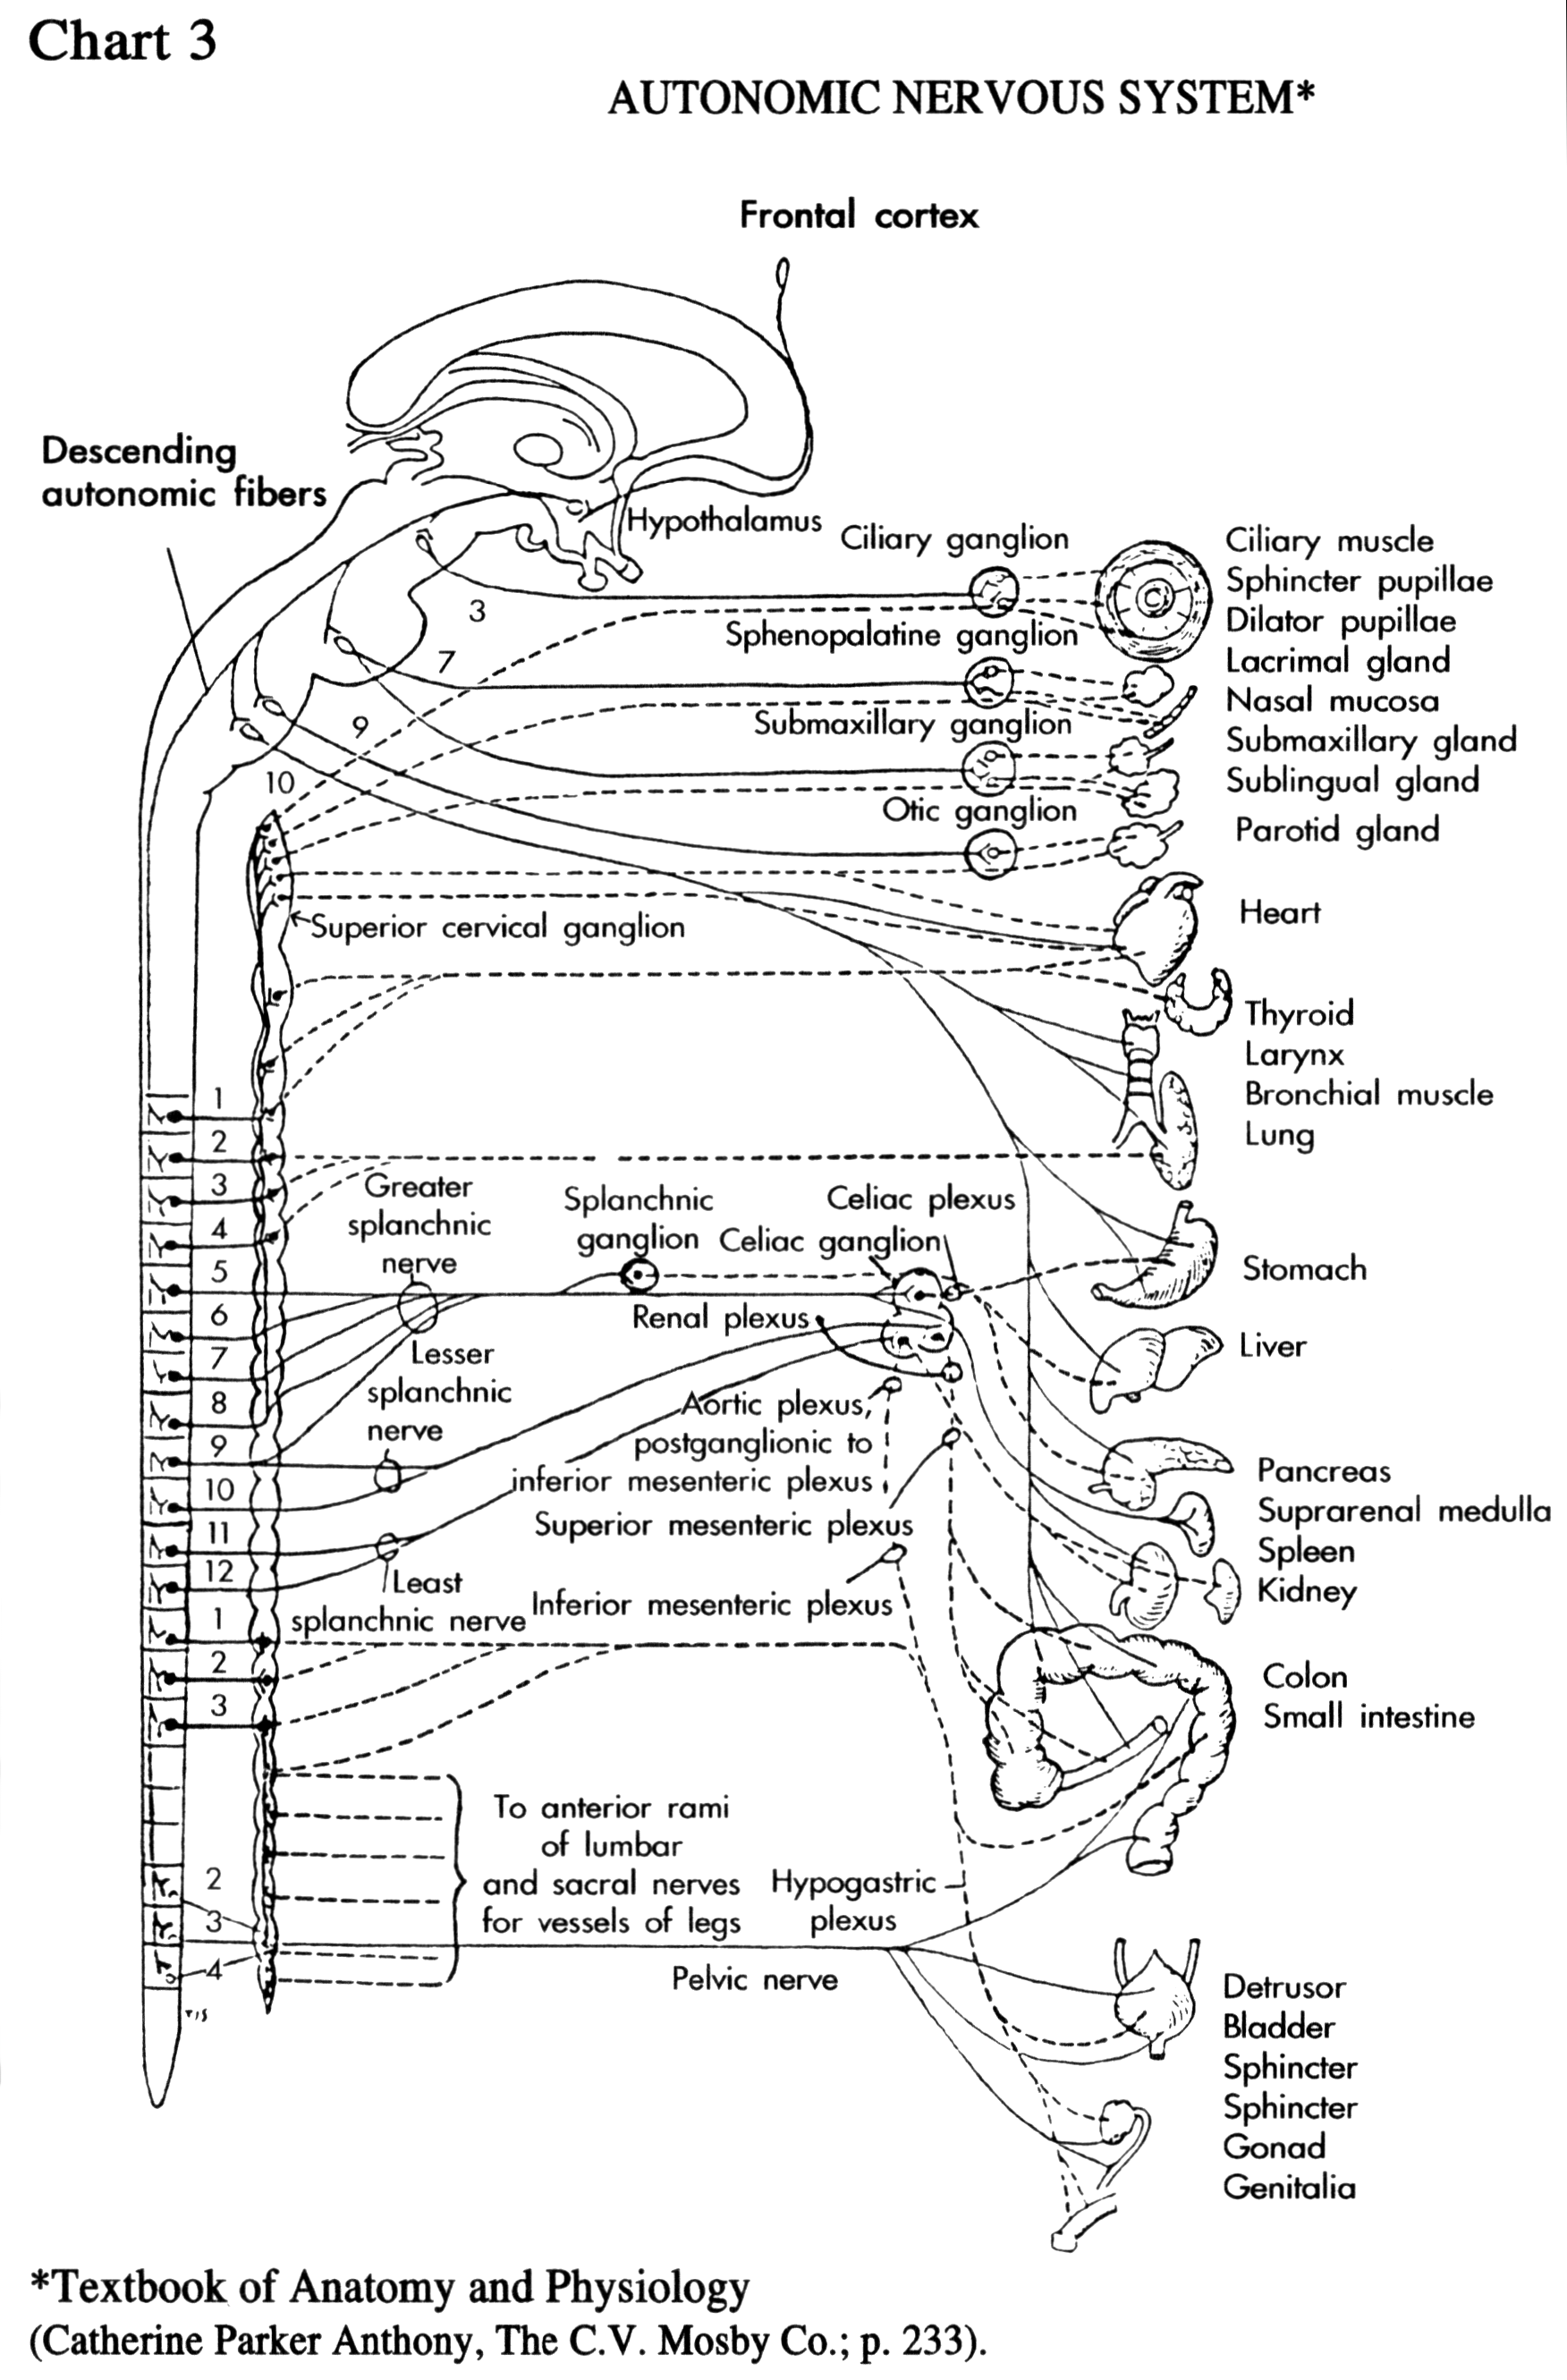
Exposure to “harmonic” music reinforces the rhythmic cycles of the body; balancing processes, synchronizing nerve messages, bringing moods and emotions into a rest state of homeostasis, as well as enhancing coordination (to be discussed later). Exposure to “disharmonic” music—whether it be the “tension” caused by dissonance and “noise” or the unnatural swings of misplaced rhythmical accents, syncopation, and polyrhythms, or inappropriate tempo— can result in a variety of changes including:
- An altered heart rate with its corresponding change in blood pressure;
- An overstimulation of hormones (especially the opiates or endorphins) causing an altered state of consciousness from mere exhilaration on one end of the spectrum to unconsciousness on the other; and improper digestion.
So deep seated is our body’s association with certain elements of music that…
“...short of numbing the entire brain, neurologists have been unable to suppress rhythmic ability. Doping either side of the brain, or many regions at once, still leaves the patient able to count or clap in time.” (Michael Segell, “Rhythmatism,” American Health, December 1988, p. 60)
“In ancient as well as modern civilization, music has helped to synchronize the movements of workers. In fact, many folk songs originated in this way. Of course, the music also helped to relieve the monotony of their toil.” (H. Lloyd Leno, “The Power of Music,” Our Firm Foundation, January 1987, p. 19)
Experiments in offices and industries have led to the conclusion that the rhythm of the music effects the precision or accuracy of the work.
“Specially selected music increases the working capacity of the muscles. At the same time, the tempo of the movements of the worker changes with the change of the musical tempo. It is as if the music determines a good rapid rhythm of movement.” (Leonid Malnikov, “USSR: Music and Medicine,” Music Journal, XXCII, November 1970, p. 15)
But, for example,
“when the rhythm is contrary to the speed of typewriting, there (is) a decrease in accuracy.” (Coris Soilbelman, op. cit., p. 47)
This same loss of coordination can be experienced by mixing rhythmic stimuli such as a strobe light pulsating at a different and non-synchronized rate of speed from the music of the band. Under such circumstances, movements become erratic and halting.
The secret behind this apparent manipulation is that...
“...sound vibrations acting upon and through the nervous system give shocks in rhythmical sequence to the muscles, which cause them to contract and set our arms and hands, legs and feet in motion. On account of this automatic muscular reaction, many people make some movement when hearing music; for them to remain motionless would require conscious muscular restraint.” (Van de Wall, op. cit.)
It is obvious then that the body responds to the stimuli without a conscious or unconscious judgment as to whether or not the incoming rhythm is compatible with its own functions.
Even casual observance bears out the veracity of these statements. Consider such ordinary activities as dancing and marching. While the music is playing or the march beat is being counted aloud, all can move in perfect synchronization. But within seconds of the cessation of such rhythmic stimuli, such harmony soon disappears. Each begins to move to the beat of their own internal clockwork, few of which are going to be exactly the same.

How Far Is Too Far?
It is obvious then that...
- The body is deeply rhythmical and that
- Each individual has his own clock ticking out his own rhythm of homeostasis. But it is also just as obvious that
- These individual rhythms may be voluntarily submitted or simply overridden by outside rhythmic stimuli. If we can alter the body’s natural rhythmic swings simply by exposing it to outside stimuli that differ in rhythm and tempo from its own, and we can, the question then is; to what extent is this overriding process safe?
An article concerned with this very question has this to say:
“Man is essentially a rhythmical being...There is rhythm in respiration, heart beat, speech, gait, etc. The cerebral hemispheres are in a perpetual state of rhythmical swing day and night. To maintain a sense of well-being and integration, it is essential that man is not subjected too much to any rhythms not in accord with his own natural bodily rhythms.” (Emphasis supplied.) (American Mercury, September 1961, p. 46; Ibid., p. 46)
Most research seems to point to this one factor—compatibility between the rhythms (or beats) of the music and rhythms of the body—as the most influential in the success or failure of harmonically integrating man and music. If the tempo of the music is faster than the normal tempo of the body, the consequences are generally a quickening and overstimulation of the body processes.
Likewise, the opposite is true of a very slow-tempoed music. Such results have led some to conclude that…
“tempo may be the most important factor for our hearts and our heads. Our hearts normally beat 70 to 80 times per minute. Most Western music is set (coincidentally?) to this tempo.” (Robert E. Ornstein, Ph.D., and David S. Sobel, M.D., “Healthy Pleasures,” American Health, May 1989, p. 58)
So, how far out of sync is too far? Any pull or push that causes the body to have to fight for homeostasis is a “pull or push” too far. Naturally, the results, immediate or lasting, depend on the extent of exposure, the extent of deviation from the norm, as well as one’s personal strength and level of resistance to foreign states of being. This is true of any species within the animal kingdom and, of course, we know it to be true of the inanimate world of machines and appliances: too little power input and it doesn’t work, too much and you “fry” the controls.

2. How Am I Behaving?
In a healthy state of balance mentally, physically, and emotionally, one can expect, and usually find, a person’s processes of judgment and decisions to also be balanced, calm, and under control. We say they are “well adjusted.” Little traumas don’t move them far away from their smooth ride. Others observe them and think that they are “so even.” We like this characteristic in leadership because it gives a real sense of stability and security. Harmonic music reinforces this state of balance.
The flip side of this, however, is a very different picture. Remember that one of the functional changes with disharmonic music is the release of too-high doses of opiates and other hormones. This creates an overcharged emotional state. Some of these emotional traumas come to us in a way that we are able to recognize easily such as the fear that we experience at the scene of an accident or in a fire, or some other life-threatening situation. We can feel our hearts pounding; we sense the cold sweat and we literally fight with ourselves to keep calm, cool, and collected. If we should lose control, if our body is unable to bring us back to a state of homeostasis, we might do any number of very foolish things or we may slip into an unconscious state of shock.
But other emotional “highs” steal up on us very much unnoticed. Perhaps the most classic example of this is the emotional high of sentimental love—a state so obvious to everyone else and so totally unobserved by the person(s) involved. In this condition, one can be given every logic, spared no words or evidences, bribed, beaten, and flogged, but nine times out often (at least) will continue as is, till the emotional high burns out. Judgment is impaired, important decisions are boggled, and improper behavior follows. In fact, the most obvious evidence of emotional disturbance is altered behavior. (Harold Shryock, M.S., Hubert O. Swartout, M.D., Dr. P.H., You and Your Health, (Pacific Press Pub. Assoc., 1970), Vol. 3, p. 132)
In early literature, the processes in which the body engages to maintain homeostasis of the emotions is referred to as the inhibitory and excitatory processes. Very simply, the inhibitors can be likened to the brakes of a car and the excitors to the gas. When one applies both the gas and the brakes at the same time, the car cannot move ahead smoothly. One or the other process gives way, causing the car to halt or speed away out of control.
Such an emotional state is simply referred to as “neurosis.” We all quickly associate this word with deviant behavior—extreme introversion, despondency, and depression, to nervousness, wild unpredictable behavior and extreme aggression. Such a state can also cause hyperactivity, heightened mob instinct, abnormal fears, bad attitudes, and lethargic or lazy behavior, as well as impaired memory and learning processes.
This last fact is what has educators and learning/memory specialists all excited. When it was discovered that rock music is disharmonic, and that it causes behavior disorders, including problems with learning and memory, a very quick mandate spread around—“Don’t study while listening to rock music.” (Seminars given by: College Point Corporate Part., 129-09 26th Ave., Flushing, New York, 11356)
Many, realizing that this is the only kind of music most people listen to, have gone so far as to instruct would-be learners to not study to music, period. (Murray Rockowitz, Ph.D., Samuel C. Brownstein, and Max Peters, How to Prepare for the GED, (New York: Barron’s Educational Series, Inc., 1988) p. 9)
So disorders caused by disharmonic music can range from “the intoxication of the dance” (Carles W. Hughes, “Rhythm and Health,” Music and Medicine, ed. by Dorothy Shullian and Max Schoen (New York: Henry Schuman Inc., 1948), 186, 187) to wild frenzies—even seizures (Michael Segell, op. cit., p. 59); from suicide to violent aggression. Whether the unbalancing of the mind is little or great, the judgment impaired slightly or grossly, the behavior altered briefly or continually, the fact is that while in a state of emotional imbalance, judgment cannot be trusted, thus behavior also slips out of sync.
But please remember, impaired judgment and improper behavior might be obvious to the individual affected but more often than not, they are the last to realize it. There they are, out of balance, out of sync, out of harmony—not necessarily with others in their society, but within themselves, with nature, and unfortunately, with the God of creation.
Let’s briefly review what we have learned so far and tie up any loose ends.
- Music affects society. This effect may be either uplifting (positive), or degrading (negative).
- All of God’s creation is harmonious and rhythmical.
- Man is essentially a rhythmical being.
- Every component of music is rhythmical.
- Music affects man’s rhythmic processes directly through the nervous system, bypassing the higher centers of reason and judgment via the auditory nerves.
- Music directly affects the autonomic nervous system thus having the potential to affect all of its systems.
- a. Man has a balance system—the inhibitory and excitatory process—which is both directly and indirectly affected by negative stress stimuli which includes any rhythmical or cyclic disruption as is experienced by disharmonic musical sounds,
b. When this process becomes unbalanced, and the body cannot correct the imbalance quite promptly, behavior disorders result such as hyperactivity, aggressiveness, impaired judgment, heightened mob instinct, impaired memory and learning processes, breakdowns in health, abnormal fears, bad attitudes, and lethargic or lazy behavior, to name a few.
- These facts apply to every human being regardless of ethnic origin or cultural background. (Because music bypasses the higher centers of reason and judgment, these effects are universal to mankind. (Max Shoen, Psychology of Music, (New York: Ronald, 1940), p. 89) In fact, to all mammalians.) The question may be raised here: Can man, through the employment of his higher centers alter these effects? The answer is: To a certain extent, yes. But only while listening to the music critically. (G. Harrer and H. Harrer, op. cit., pp. 45, 46)

3. Structural Breakdown
For our discussion of structural changes brought about by disharmonic music I want to share a research project completed in 1988 that speaks eloquently to the issue.
Two researchers, Dr. Schreckenberg, a neurologist, and Dr. Bird, a physicist, wanted to discover if there would be any effect and, if so, what the effect might be, of harmonic and disharmonic music on neuronal mechanisms of the brain. Because no previous studies had been done, to their knowledge, that established what kind of music was harmonic and what kind of music was disharmonic, they found it necessary to carry out preliminary studies. These preliminary laboratory studies…
“established that classical musical stimuli with synchronized component rhythmic patterns provided a '‘harmonic’ sound environment, and that musical stimuli with non-synchronized component rhythms (typical of the polyrhythms of African music and the syncopation of Western rock ‘n’ roll) provided a ‘disharmonic’ sound environment.” (Gervasia M. Schreckenberg and Harvey H. Bird., op. cit., p. 78)

The Process:
Thirty-six mice were divided at birth into three categories:
(C) the control group, (H) the harmonic group (those exposed to the harmonic music), and (D) the disharmonic group (those exposed to disharmonic music).
For two months the (H) and (D) groups were exposed, night and day, to their respective music, maintained at a sound level of 80-85 decibels. The (C) group was kept in a relatively quiet room at 75 decibels. The environments were in all other ways identical.
After these two months of exposure, 12 mice, four from each group, were sacrificed and their brains properly prepared and frozen for later study and comparisons with what would be the older mice by the time all had been sacrificed for study.
The other 24 mice were exposed to three weeks of maze “training.” Then they were given three weeks of rest during which time no testing or maze reinforcement occurred. This was followed by a three week post latency period during which the mice were retested to establish the degree of learning and retention. Throughout this process, behavior changes and discrepancies were carefully noted. At the completion of the maze training, these 24 mice were sacrificed and their brains were studied along with the previous 12.

The Results:
- The (C) and (H) groups were very similar, no significant differences appeared.
- The (D) group showed the following changes:
  - Excess branching of the Neuronal dendrites. (Notice Chart 2 below)
  - Significant increases in mRNA (messenger Ribonucleic acid).
  - Significant decreases in learning retention or memory.
  - Hyperactivity.
  - Aggression (during the three month preliminary testing, some mice resorted to cannibalism. Established by talking to Dr. Bird.)
  - Lethargy and inattentiveness.
This all translates into two simple phrases we can all understand: The disharmonic music causes 1) brain nerve damage and 2) behavior degradation. (Ibid., pp. 77-86)
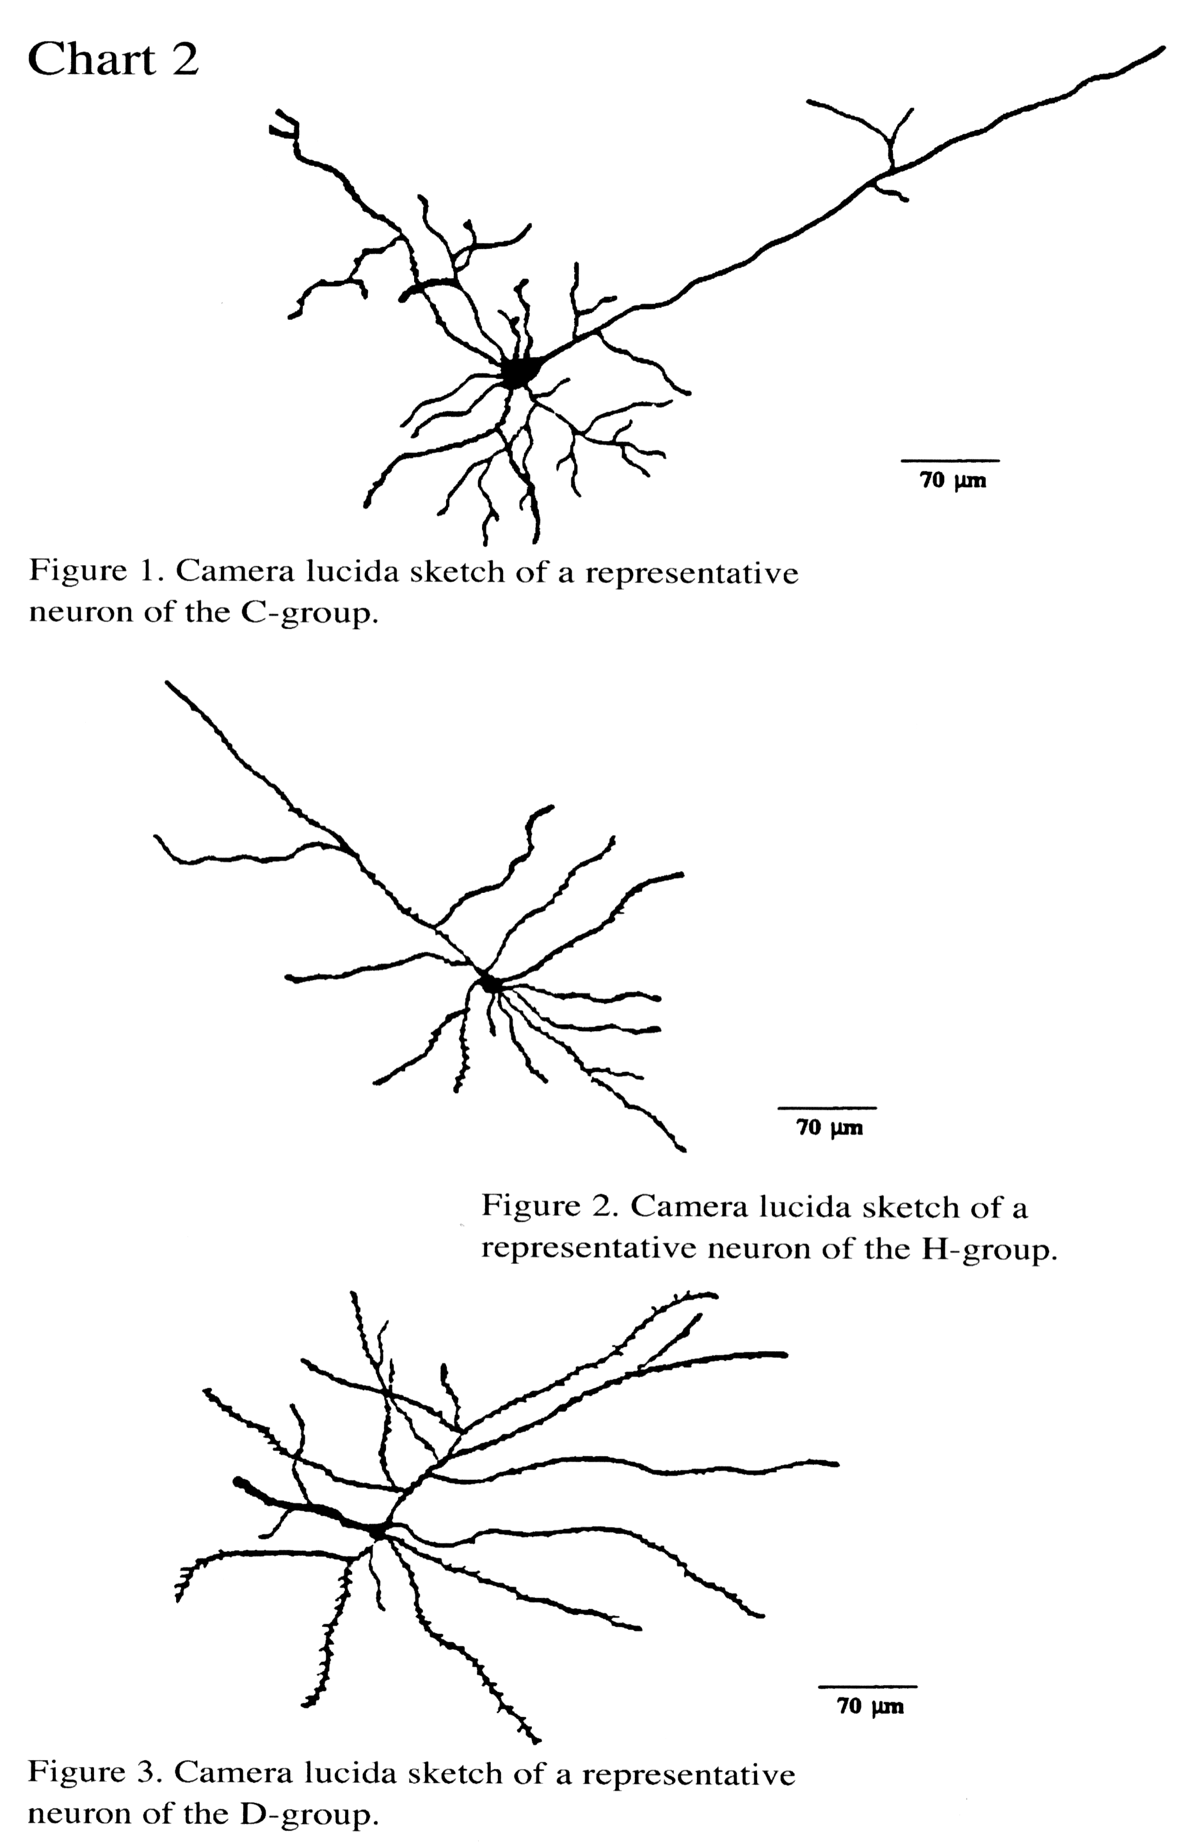

The Conclusion
Yes, rhythm rules. Our only choice in the matter is to what rhythms we will expose ourselves; to the rhythms of harmony, or to the rhythms that disturb harmony? Contrary to what many of us have previously believed, there truly is no middle road with music. It either enhances the Creator’s design and nature’s pull “toward optimum (harmonic) balance” (Ibid., p. 84) or it interferes with the balance so necessary for our health mentally, physically, emotionally, and spiritually. It is either uplifting or degrading.
May our choice ever be to cooperate with our God that His desire for our lives might be realized: “That (we) might have life and have it more abundantly!” (John 10:10)

